Fly Emirates - Flight Delay & Cancellation Analysis

1. Project Overview
This project analyzes operational performance in the U.S. aviation industry using a dataset containing over 15 million historical flight records. The objective of the analysis is to identify the primary drivers of flight delays, cancellations, and diversions, and evaluate the operational performance of airlines and airports. By analyzing key performance indicators such as delay averages, cancellation counts, and diversion patterns, the project aims to generate data‑driven insights that can help airlines improve scheduling efficiency and reduce operational disruptions.

2. Dataset Overview
The dataset contains detailed information on flight operations including airlines, airports, flight schedules, delay causes, cancellations, and diversions. The dataset consists of more than 15 million records representing flight activity across major U.S. airports.
**The data was cleaned and integrated using SQL before being connected to Power BI for visual analysis.

3. Dashboard Overview
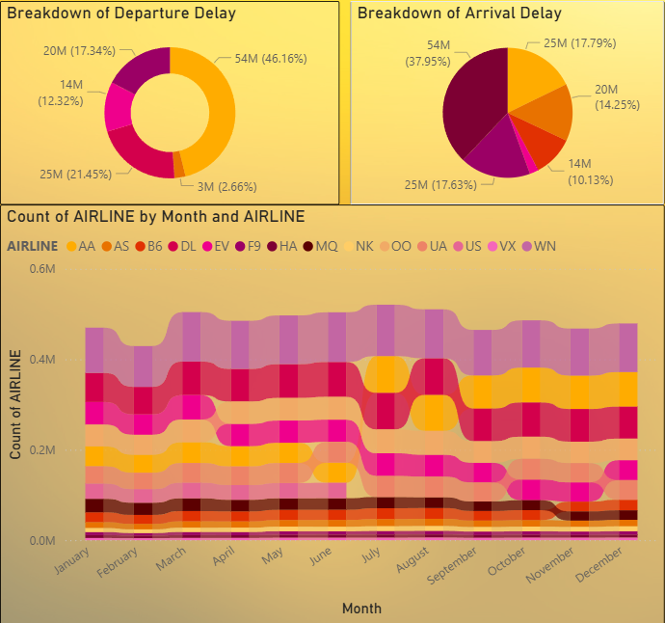
The Power BI dashboard was developed to provide an interactive and data-driven analysis of airline operational performance using the integrated flight dataset. The dashboard consists of multiple analytical pages including Operational Overview, Delay Analysis, Cancellation Analysis, Airport Disruption Analysis, and Correlation Analysis, allowing stakeholders to explore operational patterns and identify key drivers behind flight disruptions.
The dashboard integrates several visualization techniques such as KPI cards, bar charts, stacked charts, scatter plots, and geographic maps to present insights in a structured and interactive format. A geographic map visualization highlights the distribution of flights across major U.S. airports, helping identify regions with higher air traffic density and potential congestion. The dashboard also includes time-based visualizations that analyze flight activity and disruptions across months, days of the week, and seasonal patterns, enabling the identification of operational trends.
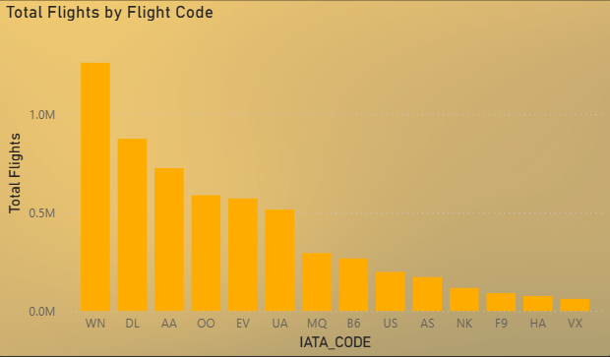From the analysis, the dataset records approximately 6 million flights, with about 90,000 cancelled flights and nearly 15,000 diverted flights. The dashboard reveals that July experiences the highest flight traffic with approximately 521,000 flights, indicating peak travel demand during the summer season. In contrast, February records the highest number of cancellations with approximately 20,517 cancelled flights (around 23% of all cancellations), followed by January with about 11,982 cancellations, suggesting that winter weather conditions significantly impact airline operations.
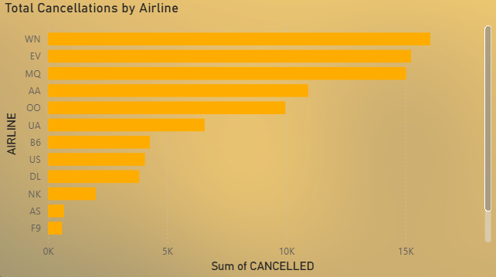
Airport traffic analysis shows that Hartsfield-Jackson Atlanta International Airport (ATL) handles around 346,904 flights, followed by Chicago O’Hare International Airport (ORD) with approximately 285,906 flights, making them among the busiest operational hubs in the dataset. Additionally, records with missing airport names (identified with unique IDs) account for approximately 486,165 flights, highlighting the importance of proper data labeling during analysis.
The cancellation analysis further reveals geographic disruption patterns. Texas records the highest number of cancellations with about 13,441 cancelled flights, followed by Illinois with 11,683 cancellations and California with 8,023 cancellations. These states host major aviation hubs, which explains their higher exposure to operational disruptions.
Airline-level analysis indicates that Southwest Airlines (WN) experiences the highest number of cancellations with approximately 16,043 cancelled flights, followed closely by ExpressJet Airlines (EV) with 15,231 cancellations and Envoy Air (MQ) with 15,025 cancellations. These airlines operate large flight volumes, which increases their exposure to operational disruptions.
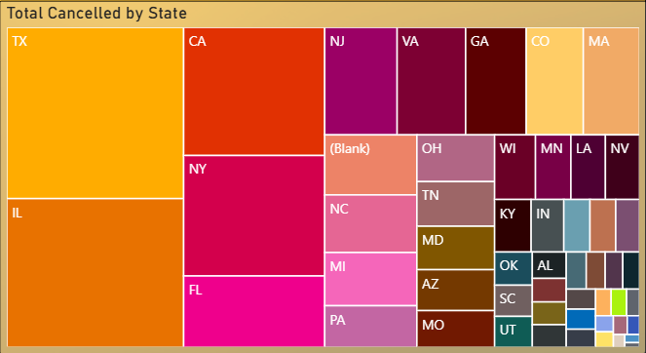
Temporal analysis also highlights patterns across the week. Day 1 of the week records the highest number of cancellations with approximately 21,073 cancelled flights, followed by Day 7 with around 13,165 cancellations, suggesting that operational disruptions may be influenced by scheduling cycles or travel demand fluctuations.
In addition to cancellation patterns, the dashboard also evaluates delay performance metrics. The analysis shows that average departure delays are approximately 9.37 minutes, while average arrival delays are around 4.41 minutes, indicating that most disruptions originate before flight departure rather than during flight operations. Correlation analysis further reveals strong relationships between delay variables, with correlation values ranging from 0.79 to 0.89, demonstrating that delays in one stage of the flight process often propagate to later stages.
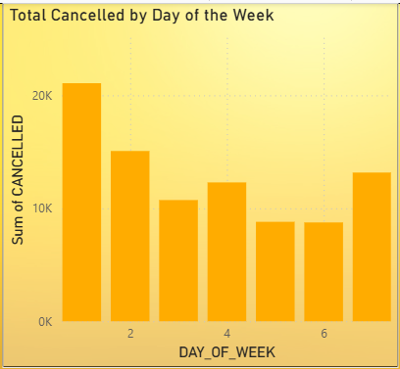
Overall, the Power BI dashboard enables a comprehensive evaluation of airline operations by combining traffic trends, delay analysis, cancellation patterns, airport performance metrics, and correlation insights, providing stakeholders with a powerful tool to monitor operational performance and identify opportunities for improving airline efficiency and reducing disruptions.

4. Operational Overview (Page 1)
The Operational Overview dashboard provides a high-level summary of airline activity across the United States during the analysed period. The dataset contains approximately 6 million recorded flights, out of which nearly 90,000 flights were cancelled, representing roughly 1.5% of total scheduled operations. Over this period, flights collectively traveled close to 5 billion miles and accumulated approximately 649 million minutes of total air time, illustrating the extensive scale and operational complexity of the U.S. aviation network.
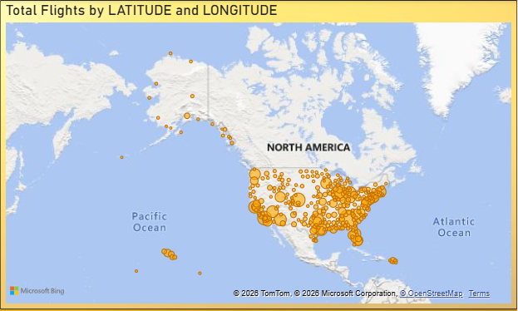
This overview page consolidates several key performance indicators (KPIs) that capture the overall state of flight operations. These include the total number of flights operated, total distance covered, total air time, and total flights cancelled, providing a comprehensive snapshot of system-wide activity. Together, these metrics establish the operational baseline against which delays, cancellations, and performance inefficiencies can be evaluated.
Geographical analysis is also incorporated through longitude and latitude-based visualizations, which map the spatial distribution of flights across the country. These visuals highlight major aviation hubs and reveal how flight traffic is concentrated around key airport corridors. Such geographic insights provide context for understanding how network structure and airport concentration influence operational performance.

The dashboard further presents airline-level operational distribution, showing the total number of flights operated by each airline code. This visualization highlights the relative operational scale of different carriers and helps identify airlines with the highest traffic volume. By benchmarking flight volumes across airlines, the dashboard provides a foundation for later comparisons of performance metrics such as delays and cancellations.
In addition to airline comparisons, the overview also includes temporal patterns of flight activity, allowing analysis of how flight volumes change across months and days of operation. These temporal views help identify peak operational periods and seasonal variations in airline activity, which are important for understanding demand patterns and operational pressure on the aviation system.
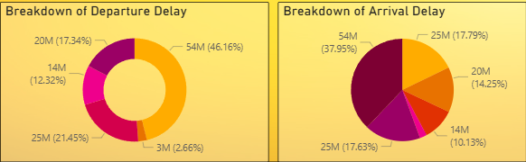
Finally, the dashboard includes breakdowns of both departure delays and arrival delays, offering an initial perspective on operational disruptions. By summarizing delay patterns at an aggregate level, the overview page establishes a starting point for deeper analysis into the causes, patterns, and operational drivers of flight delays explored in subsequent dashboard sections.
Key Takeaways and Suggestions from this page: The analysis shows that Southwest Airlines (WN) remains the most consistently used airline across all months and quarters, indicating strong and stable demand. In contrast, Delta (DL) and ExpressJet (EV) show a gradual decline in usage over the quarters, while American Airlines (AA) remains relatively stable in Quarter 1 and Quarter 2 but experiences a significant increase in Quarter 3 and Quarter 4. Additionally, flight usage is highly concentrated among the top 7 airlines, while the remaining airlines are chosen significantly less frequently.
In terms of delay analysis, departure delays account for approximately 46% of arrival delays, indicating that delays often propagate from earlier flight operations. Late aircraft delays (21.45%) and airline operational delays (17.3%) also contribute significantly to arrival delays, while weather delays contribute the least. For departure delays, the largest cause is late aircraft delays (~40%), followed by air traffic system delays (~32%) and airline operational delays (~22%). Overall, the analysis suggests that operational inefficiencies and aircraft turnaround delays are the primary drivers of flight disruptions rather than weather conditions.

5. Delay Analysis (Page 2)
The delay analysis page provides a detailed examination of flight delay patterns by comparing both departure delays and arrival delays across the dataset. The results indicate that the average departure delay is approximately 9.37 minutes, which is significantly higher than the average arrival delay of about 4.41 minutes. This difference suggests that most operational disruptions originate before the aircraft departs, typically during stages such as aircraft preparation, passenger boarding, baggage handling, or ground operations at the airport. Despite these delays at departure, airlines often recover part of the lost time during the flight through operational adjustments such as optimized cruising speeds or schedule buffers.
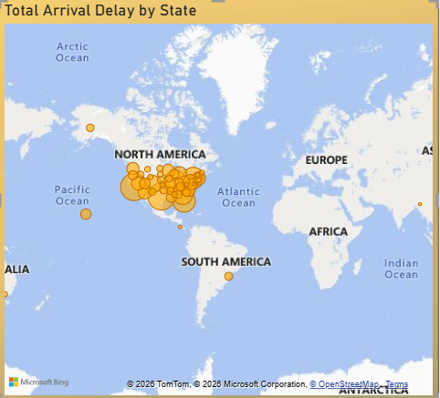
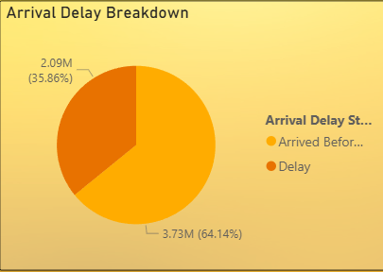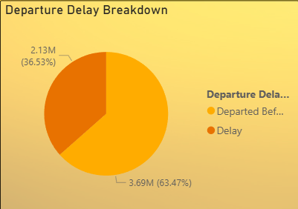
The delay distribution further reveals that approximately 64% of flights either depart or arrive on time or earlier than scheduled, while around 36% of flights experience delays. Although the majority of flights maintain schedule reliability, the proportion of delayed flights still represents a significant operational challenge for airlines and airport authorities.
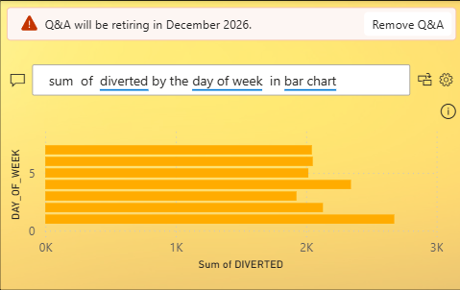
Additionally, the dataset records nearly 15,000 diverted flights, highlighting the impact of severe operational disruptions that prevent flights from reaching their intended destinations. Diversions are typically caused by factors such as extreme weather conditions, airport congestion, runway closures, or air traffic control restrictions, which require flights to reroute to alternative airports.
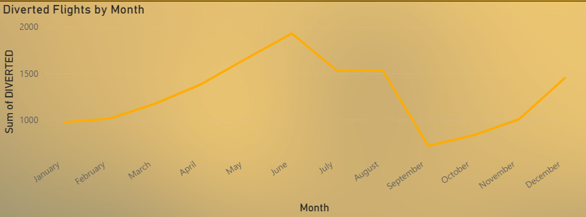
Overall, the analysis indicates that pre-departure operational inefficiencies and airport-level constraints play a major role in flight delays, while airlines often attempt to mitigate these disruptions during flight operations.
Key Takeaways and Suggestions from this page: The delay breakdown analysis shows that the majority of flights maintain schedule reliability. For arrival delays, approximately 64% of flights arrive on time or earlier than scheduled, while around 35–36% of flights experience delays. A similar pattern is observed for departure delays, where about 63% of flights depart on time or earlier, while roughly 36.5% of flights experience departure delays. This indicates that although most flights operate within schedule, a notable portion still faces operational disruptions.
The monthly diversion trend highlights fluctuations in flight diversions throughout the year. Diversions gradually increase from January through May, reaching their highest levels around June, followed by another peak during August. After August, diversion counts decline until September, before rising again toward the end of the year between September and December. This pattern suggests a seasonal volatility in flight diversions, potentially influenced by factors such as weather conditions, travel demand, and airport congestion during peak travel months.
Additionally, the dashboard includes a Q&A visual feature, which allows users to interactively explore the dataset by asking natural language questions. This functionality enables users to dynamically generate visualizations and analyse different operational factors beyond the predefined charts. For example, users can explore metrics such as taxi-in time, taxi-out time, wheels-in, or wheels-out operations, allowing greater flexibility to investigate operational patterns and uncover additional insights from the dataset.

6. Cancellation Analysis (Page 3)

The cancellation analysis page examines the patterns, causes, and temporal trends of flight cancellations across the dataset. Out of approximately 6 million flights analyzed, around 90,000 flights were cancelled, representing about 1.5% of total flight operations. Among the primary causes, carrier-related operational issues account for the largest share with approximately 49,000 cancellations, indicating that airline operational factors such as crew availability, aircraft maintenance, or scheduling constraints play a significant role. Weather-related disruptions contribute around 25,000 cancellations, while NAS (National Airspace System) issues account for roughly 16,000 cancellations, reflecting delays caused by air traffic congestion or system limitations.
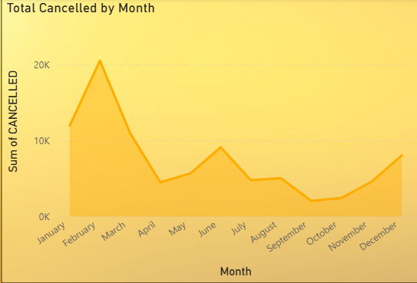
The analysis also highlights clear temporal patterns in cancellation trends. Cancellation volumes are significantly higher during the winter season, with February recording the highest number of cancellations at approximately 20,517 flights, followed by January with around 11,982 cancellations. These peaks suggest that severe winter weather conditions have a substantial impact on airline operations, leading to increased flight cancellations during these months. Overall, the findings indicate that both airline operational challenges and seasonal weather disruptions are key contributors to flight cancellations within the aviation network.

Key Takeaways and Suggestions from this page: The cancellation analysis shows that flight cancellations are primarily driven by airline operational issues, with carrier-related causes accounting for the largest share at approximately 49,000 cancellations. Weather disruptions are the second major contributor with around 25,000 cancellations, while NAS (air traffic system) issues account for roughly 16,000 cancellations.
Additionally, cancellation trends show a strong seasonal pattern, with the highest number of cancellations occurring during winter months, particularly February (20,517 cancellations) followed by January (11,982 cancellations). This indicates that severe winter weather conditions significantly impact airline operations and increase the likelihood of flight cancellations.

7. Airport Disruption Analysis (Page 4)
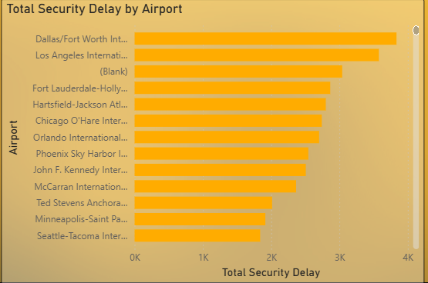
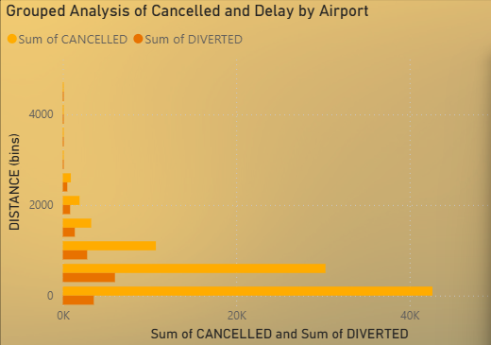
The airport disruption analysis highlights that major aviation hub airports experience the highest levels of operational disruptions, primarily due to their large flight volumes and complex operational environments. Airports such as Hartsfield–Jackson Atlanta International Airport (ATL), Chicago O’Hare International Airport (ORD), and Dallas/Fort Worth International Airport (DFW) record the highest numbers of flight cancellations and diversions. These airports serve as major connection hubs within the U.S. aviation network, handling a large share of national air traffic, which increases the likelihood of disruptions when operational challenges occur.

Because hub airports manage thousands of daily flight movements, even small operational issues such as aircraft turnaround delays, runway congestion, weather disruptions, or air traffic control constraints can quickly propagate through the flight schedule. As a result, disruptions at these high-traffic airports tend to impact multiple flights, leading to higher cancellation and diversion counts compared to smaller regional airports.
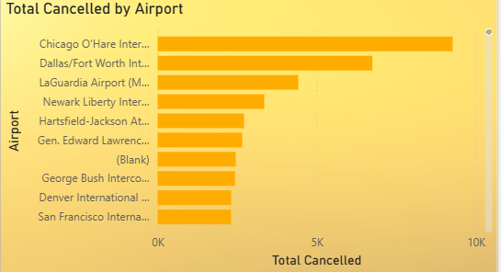
The analysis also reveals that security-related delays across major airports accumulate to approximately 81,000 minutes. These delays reflect additional operational pressures caused by security screening procedures, passenger congestion, and airport infrastructure limitations. While security delays may represent a smaller share of overall delay causes, their cumulative impact contributes to operational inefficiencies, particularly in high-traffic airports where passenger volumes are significantly higher.
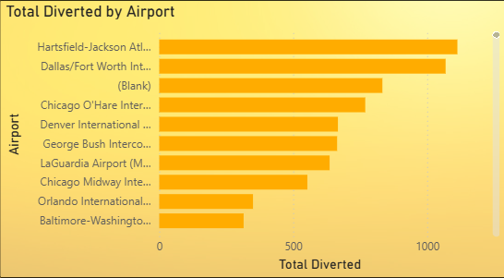

Overall, the findings indicate that airport congestion, high passenger traffic, and the operational complexity of major hub airports are key drivers of disruptions, highlighting the importance of efficient airport operations and infrastructure management to reduce delays, cancellations, and diversions across the aviation network.
Key Takeaways and Suggestions from this page:
• Major hub airports experience the highest disruptions: Airports such as ATL, ORD, and DFW record the largest number of flight cancellations and diversions due to their high flight traffic and operational complexity.
• Traffic volume drives disruption levels: High-traffic hub airports handle thousands of flights daily, increasing the likelihood that operational issues will cascade across multiple flights.
• Security delays add operational pressure: Security-related delays across major airports accumulate to approximately 81,000 minutes, contributing to congestion and scheduling inefficiencies.
• Operational complexity at hubs: Factors such as runway congestion, aircraft turnaround delays, and air traffic control constraints further increase the risk of disruptions at major airports.
• Overall insight: Airport congestion and operational complexity at major hubs are key contributors to cancellations, diversions, and overall flight disruptions within the aviation network.

8. Correlation Analysis (Page 5)
The correlation analysis highlights the strong relationships between different delay variables within flight operations. The results show that airline delays and arrival delays have a correlation of approximately 0.79, indicating that operational inefficiencies within airlines significantly influence arrival performance. When airline operations experience delays, these disruptions often extend into the flight schedule and impact arrival times.
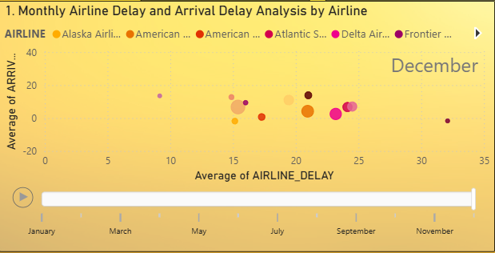
Similarly, the relationship between arrival delays and departure delays across airports shows strong correlations of approximately 0.82 and 0.89. These high correlation values suggest that delays occurring at airports are highly interconnected, where late arrivals frequently result in delayed departures for subsequent flights. This is largely due to operational factors such as aircraft turnaround times, airport congestion, and scheduling dependencies.
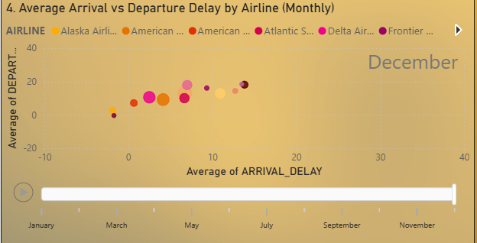
Overall, the analysis demonstrates a delay propagation effect within the aviation network, where disruptions at one stage of flight operations tend to cascade into later stages. This indicates that improving operational efficiency at early stages, particularly airline operations and airport turnaround processes, could significantly reduce overall flight delays across the system.

9. Key Findings
• 64% of flights arrive on time or early, while 35–36% experience arrival delays.
• 63% of flights depart on time or early, while about 36.5% experience departure delays.
• Approximately 15,000 flights were diverted, showing the impact of severe operational disruptions.
• June and August record the highest diversion peaks, indicating seasonal volatility in flight disruptions.
• ATL (346,904 flights) and ORD (285,906 flights) are among the busiest airports, leading to higher disruption exposure.
• Security delays total around 81,000 minutes, contributing to operational inefficiencies at major airports.
• Southwest Airlines (WN) remains the most consistently used airline across all months and quarters.
• Delta (DL) and ExpressJet (EV) show a declining usage trend, while American Airlines (AA) increases significantly in Quarter 3 and Quarter 4.
• Top 7 airlines dominate the majority of flight usage, indicating passenger preference concentration among major carriers.
• Departure delays contribute to about 46% of arrival delays, demonstrating strong delay propagation across flights.
• Late aircraft delays (~40%) are the largest contributor to departure delays.
• Air traffic system delays (~32%) and airline operational delays (~22%) are the next major contributors to departure disruptions.
• For arrival delays, late aircraft delays (~21.45%) and airline delays (~17.3%) contribute significantly.
• Weather delays contribute the least to both arrival and departure delays compared to operational factors.

10. Conclusion
Based on the analysis, improving operational efficiency at both airline and airport levels can significantly reduce flight disruptions. Since departure delays are higher than arrival delays and contribute to nearly 46% of arrival delays, airlines should focus on improving ground operations such as aircraft turnaround time, boarding processes, and scheduling coordination to minimize pre-departure disruptions. Additionally, because late aircraft delays account for the largest share of departure delays (~40%), better fleet management and tighter scheduling buffers could help prevent delay propagation across subsequent flights.
The analysis also highlights that major hub airports such as ATL and ORD handle extremely high flight volumes, making them more vulnerable to congestion and operational disruptions. Airport authorities should consider improving runway management, gate allocation, and traffic flow coordination to reduce bottlenecks. Furthermore, since security delays accumulate to around 81,000 minutes, optimizing passenger screening processes and infrastructure at busy airports could help improve operational efficiency.
Seasonal trends also indicate that diversions peak around June and August, while cancellations increase significantly during winter months such as February and January. Airlines and airports should therefore adopt seasonal contingency planning, including additional staffing, flexible scheduling, and weather disruption management strategies during peak risk periods.
Finally, since flight demand is highly concentrated among a few major airlines and busy hub airports, airlines should explore better route distribution, capacity management, and operational planning to balance traffic loads and reduce congestion. Implementing these improvements can help airlines enhance schedule reliability, reduce delays and cancellations, and improve overall passenger experience across the aviation network.

